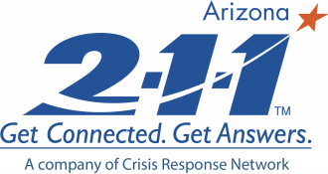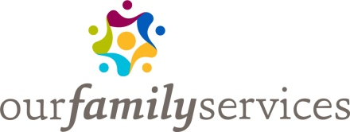

Resources for People Experiencing Homelessness or Who Are At-Risk for Homelessness in Arizona

Homeless is when a person does not have a safe, stable, and appropriate place to live. It can mean living “on the streets,” sleeping in a vehicle, or staying in an emergency shelter. Being at-risk for homelessness is when someone may become homeless very soon. This can mean couch-surfing with family or friends, staying in a motel, or receiving an eviction notice.

In Arizona, there were more than 37,000 adults and children who experienced homelessness last year. Being homeless and at risk for being homeless can lead to additional problems, including health concerns, risk of being a victim of crime or trauma, inability to find and keep a job, substance use, and mental health issues.

The links below are to services found in the 2-1-1 Arizona database. Select a link and then enter your county in the Area Served field on the right.

HOUSING RESOURCES:

- Homeless Shelters

- Missions (includes religious services)

- Rent Payment Assistance

- Mortgage Payment Assistances

- Low Income/Subsidized Rental Housing (includes housing projects & Section 8)

- Landlord/Tenant Assistance

EXTREME WEATHER SHELTERS:

- Very Hot Weather (places to go during the day to get out of the sun and get water)

- Very Cold Weather (place to spend the night when it is very cold)
ADDITIONAL RESOURCES:

- Homeless Resource Centers (may include the use of phones, restrooms, and laundry facilities)

- Showers

FOOD RESOURCES:

- Food Boxes

- Soup Kitchens

- Food Stamp/SNAP Program

- WIC Program

UTILITY ASSISTANCE RESOURCES:

- Utility Payment Assistance

- Utility Discount Programs

- Weatherization Programs (which may reduce utility bills)

ONLINE BENEFIT SCREENING:

- Finding & Applying for Additional Benefits

HEALTH CARE:

- Community Clinics

- Applying for AHCCCS/Medicaid

MENTAL HEALTH AND SUBSTANCE ABUSE:

- Referral to Service Providers

DRIVER LICENSE AND IDENTIFICATION CARDS:

- Arizona Department of Transportation Motor Vehicle Division

RECEIVE MAIL, MAKE CALLS, GET CONNECTED:

- You may qualify for a free US Post Office Box

- Free Phones (landline or cell phone)

- Free And Low Cost Computers

- Use Of Public Computers

For more information about homelessness:
- in Arizona DES Report
- in the country State of Homelessness in America

SOURCE: 2-1-1 Counts; Arizona Department of Economic Security; National Alliance to End Homelessness; National Coalition for the Homeless; United States Department of Health and Human Services - National Institutes of Health
________________________
PREPARED BY: 211/lk
CONTENT LAST REVIEWED: 9/12/2018

